**Quality Planning**

1. Definition
2. Grade
3. Statistics
   1. Control limits
   2. Normal Distribution
   3. Standard deviation
4. Quality Planning Tools
   1. Measurement terminology
      1. Tolerances
   2. Defining and meeting client expectations
5. Quality Assurance

**Definition of Quality**

1. Understand the quality levels expected
2. Ensure that the levels are met
   1. This includes measuring

**Grades as a measure of quality**

Pre-set standards

1. Octane rating for gasoline
2. Lumber graded for appearance, strength
3. Steel and other commodities

**Using statistics to measure and manage quality**

1. Control limits
   1. Upper and lower standards for allowable variation
2. Central limit theorem
   1. Frequency distribution
   2. Discrete math— “bins” –count the number of measurements that fall in each bin
   3. Normal distribution– “bell-shaped curve”

**Measuring your products**

Options:

1. Measure entire population
2. Sampling
   1. A smaller amount of data to work with
   2. Sometimes measuring destroys the sample

**Normal Distribution**

1. Standard deviation
   1. Calculate the mean (or average value) of all measurements
   2. Subtract EACH measurement from the mean
   3. Square EACH difference
   4. Sum the values
   5. Divide the sum by ( (number of values) – 1 )
   6. Take the square root
2. The result can be thought of as the average difference

**Sigma Levels**

**Quality Plan**

1. The quality plan specifies the control limits
2. Often written as the mean ± the acceptable variation
3. The size of the range is called the tolerance

**Quality planning techniques**

1. Cost-benefit analysis
2. Benchmarking
3. Experimentation design
4. Cost of Quality
5. Control Charts
6. Cause and Effect diagrams
7. Histograms
   1. Pareto diagram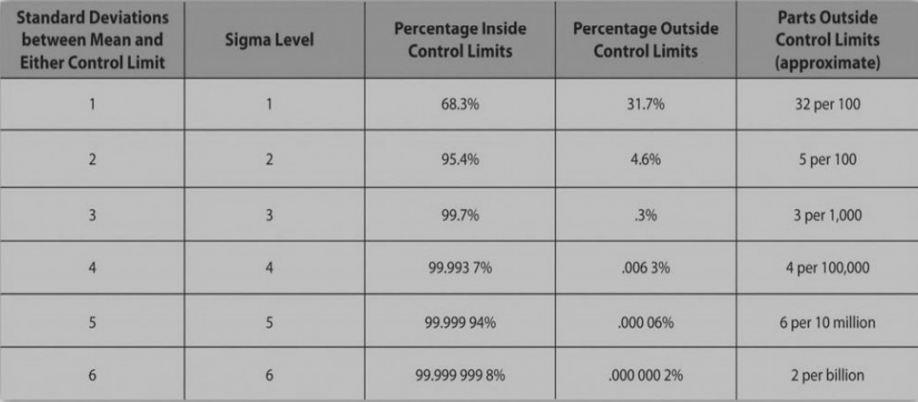

**Quality Assurance**

1. Process Analysis
   1. ISO 9000 requires this

**Summary**

1. Purpose of Quality Management:
   1. Build confidence in clients that quality standards and procedures are being followed
2. Ensured by
   1. Internal review of the plan
   2. Testing
   3. Revising policies
   4. External Review or audit